

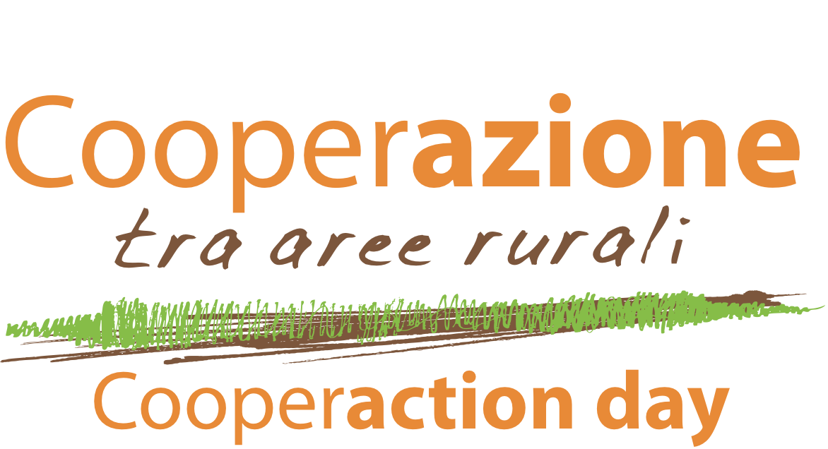

Roma, June 2011

Reservation for “Face to Face” meeting

1. Reason for reservation
Definition of partnership | Submission of agreement
Other:

2. Project idea/project
Presenting LAG
Title of the project
Type of cooperation | Interterritorial  (among different Regions) | Infra-regional | T Transnational
Macro themes of intervention | Tourism | Local Products | Quality of life

3. Fields of intervention
Rate from 1 to 4 (1 not present, 2 little relevant, 3 present but not primary, 4 primary)-
max 3 cells
Tourism | Promotion | 1 | 2 | 3 | 4
Tourism | Itineraries | 1 | 2 | 3 | 4
Local Products | Promotion | 1 | 2 | 3 | 4
Local Products | Commercialization | 1 | 2 | 3 | 4
Local Products | Information and awareness | 1 | 2 | 3 | 4
Quality of life | Social cohesion | 1 | 2 | 3 | 4
Quality of life | Cultural activities | 1 | 2 | 3 | 4
Quality of life | Information and awareness | 1 | 2 | 3 | 4
Quality of life | Services | 1 | 2 | 3 | 4
Quality of life | Land management | 1 | 2 | 3 | 4
Quality of life | Recovery of historical and cultural heritage | 1 | 2 | 3 | 4
Quality of life | Recovery of environmental heritage | 1 | 2 | 3 | 4
Quality of life | Renewable energy | 1 | 2 | 3 | 4
4. Description of the project

5. Meeting details
Number of participants | N. __________
Duration of the meeting | 30 min | 60 min

Contact details
Name and position of the task manager
Telephone
E-mail
Website

Ask for information and send this form to: delprete@inea.it
The Reservation for “Face to Face” meeting must be sent by and not beyond 11th May 2011.

