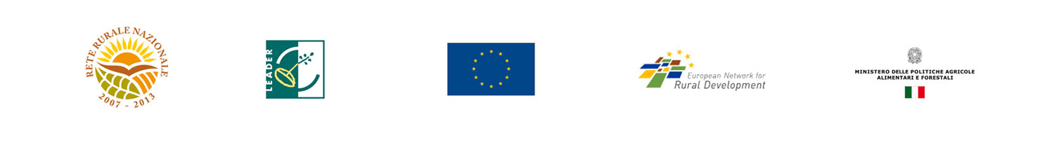
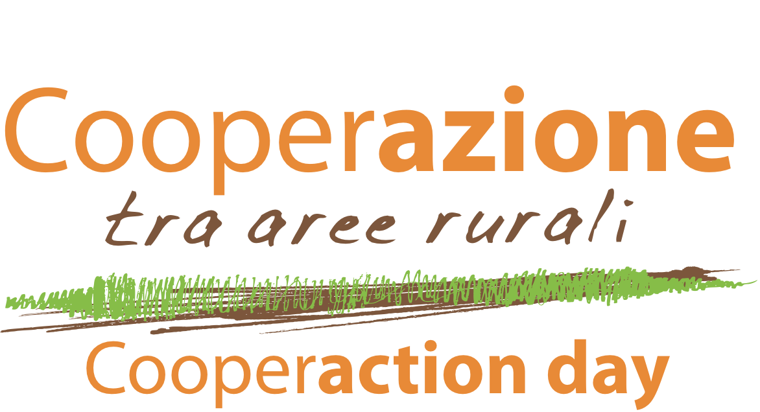
Rome, June 2011

The Italian National Rural Network is arranging an International event in support of the cooperation between rural areas. The event, meant as animation activity in the NRN Action Plan, has the aim to facilitate the creation and consolidation of partnerships within the measure 4.21 “Interterritorial and transnational cooperation” of RDP.
The one day event (from 10 a.m. to 19 p.m.) will take place in Rome and consist of:
- Thematic sessions for the presentation of cooperation project/ideas
- A Face to face meeting area
- The Cooperation offers corner
- The Cooperation show room: a place to display the results of cooperation between rural areas

THEMATIC SESSIONS
In the morning three thematic sessions will be organized on the topics of “Tourism”, “Local Products” and “Quality of life”. During these sessions the presenting Lags will be given the chance to present the cooperation project ideas sent to the Italian NRN by 11th May (using the “Project Nomination Form”). Among the projects received, Italian NRN will give priority to the project nominations already “defined”, in order to facilitate the enlargement/consolidation of the partnerships, as well as the creation of synergies with other cooperation projects. Due to organizational problems, max 22 projects will be presented for each session. Anyway, during the event all the nominations will be ensured an adequate diffusion in appropriate areas.

FACE TO FACE meetings
In the afternoon, dedicated places will be at Lags’ disposal in order to facilitate bilateral meetings.
Such bilateral meetings can spring from the ideas/projects presented in the morning as well as from other project nominations according to the requests sent to the Italian NRN by means of the Reservation for “Face to face” meeting form by 23th May.

Cooperation offers corner
The corner will be used to widespread the cooperation announcements sent to Italian NRN by Italian and European Lags/NRN using the “Partnership search” form by 23rd May.

COOPERATION SHOW ROOM
The area will be set up in order to display the results achieved with the cooperation projects over the years. The results will be shown through posters/pictures, etc… At this purpose Lags are kindly invited to send – by and not beyond the 23rd May – this sort of products summing up the project activities (posters, panels, forms,…). The material can be sent in electronic format by e-mail to lapoli@inea.it or by courier service to the following address:
INEA- Via Nomentana, 41, 00161 Roma (to Anna Lapoli- Segreteria Servizio 3)

For further information contact:

Annalisa Del Prete Tel. 00 39 06 47856123 E-mail: delprete@inea.it
Barbara Zanetti Tel. 00 39 06 47856521 E-mail: zanetti@inea.it
Catia Zumpano Tel. 00 39 06 47856522 E-mail: zumpano@inea.it

Organization office
Laura Guidarelli Tel. 00 39 06 47856455 E-mail: guidarelli@inea.it
Anna Lapoli Tel. 00 39 06 47856207 E-mail: lapoli@inea.it

